

## Department of Computer

## A DSBDAL PROJECT REPORT

## ON

# “**Movie Recommendation Model**

using Scikit Learn and Numpy library”

SUBMITTED TO THE DEPARTMENT OF COMPUTER ENGINEERING AISSMS IOIT

## TE Computer Engineering

## SUBMITTED BY



|  |  |
| --- | --- |
| **STUDENT NAME** | **ERP No:** |
| **Aniket Chopade**  **Nitish Bhise** | **20**  **13** |

## 2021 -2022



**Department of Computer Engineering CERTIFICATE**

This is to certify that the project report

# “**Movie Recommendation Model**

# using Scikit Learn and Numpy library”

Submitted by

|  |  |
| --- | --- |
| STUDENT NAME | ERP No: |
| Aniket Chopade  Nitish Bhise | 20  13 |

is a bonafide student of this institute and the work has been carried out by him/her under the supervision of **Prof. Shilpa Pimpalkar** and it is approved for the partial fulfillment of the Department of Computer Engineering AISSMS IOIT.

(**Prof. Shilpa Pimpalkar**) (**Dr. S.N.Zaware**)

Guide Head of Computer Department,

Place: Pune Date: 02/05/2022



**TABLE OF CONTENTS**

1) Title of the project

2) Abstract

3) Introduction

4) Target Content Based on Interests and Trends

5) Target Based On Platform

6) Software Requirement Specification

7) Source Code sample

8) Conclusion

**Abstract**

Recommender systems are utilized in a variety of areas, and are most commonly recognized as playlist generators for video and music services like Netflix, YouTube and Spotify, product recommenders for services such as Amazon, or content recommenders for social media platforms such as Facebook and Twitter.  
Recommender systems usually make use of either or both Collaborative Filtering or Content-Based filtering approach.

**Introduction**

Before beginning your social media data analysis, figure out what are your social media key performance indicators (KPIs). Ideally, these KPIs should be in line with your overall business strategy. Once you’ve decided on your KPIs, choosing the right tool will help you to collect and analyze data efficiently and effectively. The best tools have a simple, user-friendly interface that is intuitive and easy to manage. Using media analytics, marketers can rationalize the ROI and prove the value of social media.

Identifying and prioritizing KPIs enables brands to leverage relevant data to measure and optimize social media posting. Data can help to inform marketers, for example, on which platforms are the best match for their brand and what kind of content has the largest reach.

**Target Content Based on Interests and Trends**

Social analytics provide marketers with insights into what content, products, and advertising are creating the most buzz and interest online. Brands can leverage this information to identify top content, brand influencers, and more.

Marketers should consistently track all chatter associated with their brand online: keywords, sentiment, language, etc. Measuring actual perception versus the desired perception for a brand helps marketers recognize whether a brand is positioned correctly.

**Target Based on Platform**

Core social media KPIs help marketers to analyze data and target the unique metrics from each social media platform. Marketers need to have a strong understanding of how well content performs on each social network.

Many platforms now offer native analytics tools to better enable marketers to track and analyze data. Facebook Insights, Twitter Analytics, and Google Analytics are a few of the platform tools available for social media analysis.

Facebook Insights allow owners of a Facebook business page to analyze some internal KPIS such as engagement, impressions, likes, post reach, and reactions. Twitter Analytics shows the engagement rate, number of followers, link clicks, mentions and more in a 28-day summary. Google Analytics can provide metrics on a variety of social platforms to help brands learn about product sales, leads, visit duration, and more.

Both tracking KPIs and social network analytics helps marketers find out what posts and content performs best and how to leverage social networks accordingly.

**Software Requirement Specification**

Software Used:

* Kaggle
* Chrome or Any Web Browser

Language:

* Python

Tools:

* Jupiter Notebook
* Google Colabs

**Source Code Sample**

Import Packages:

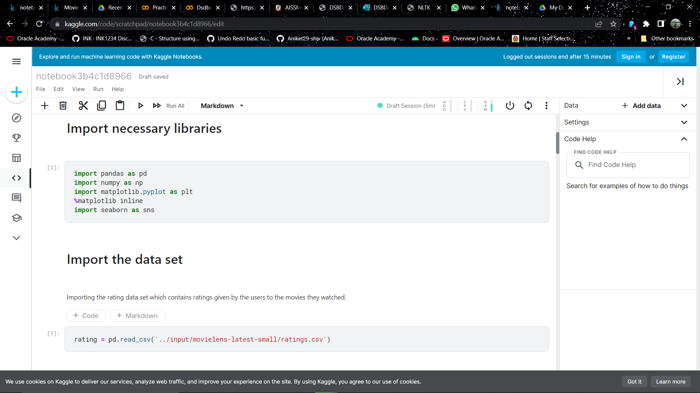

Import dataset:

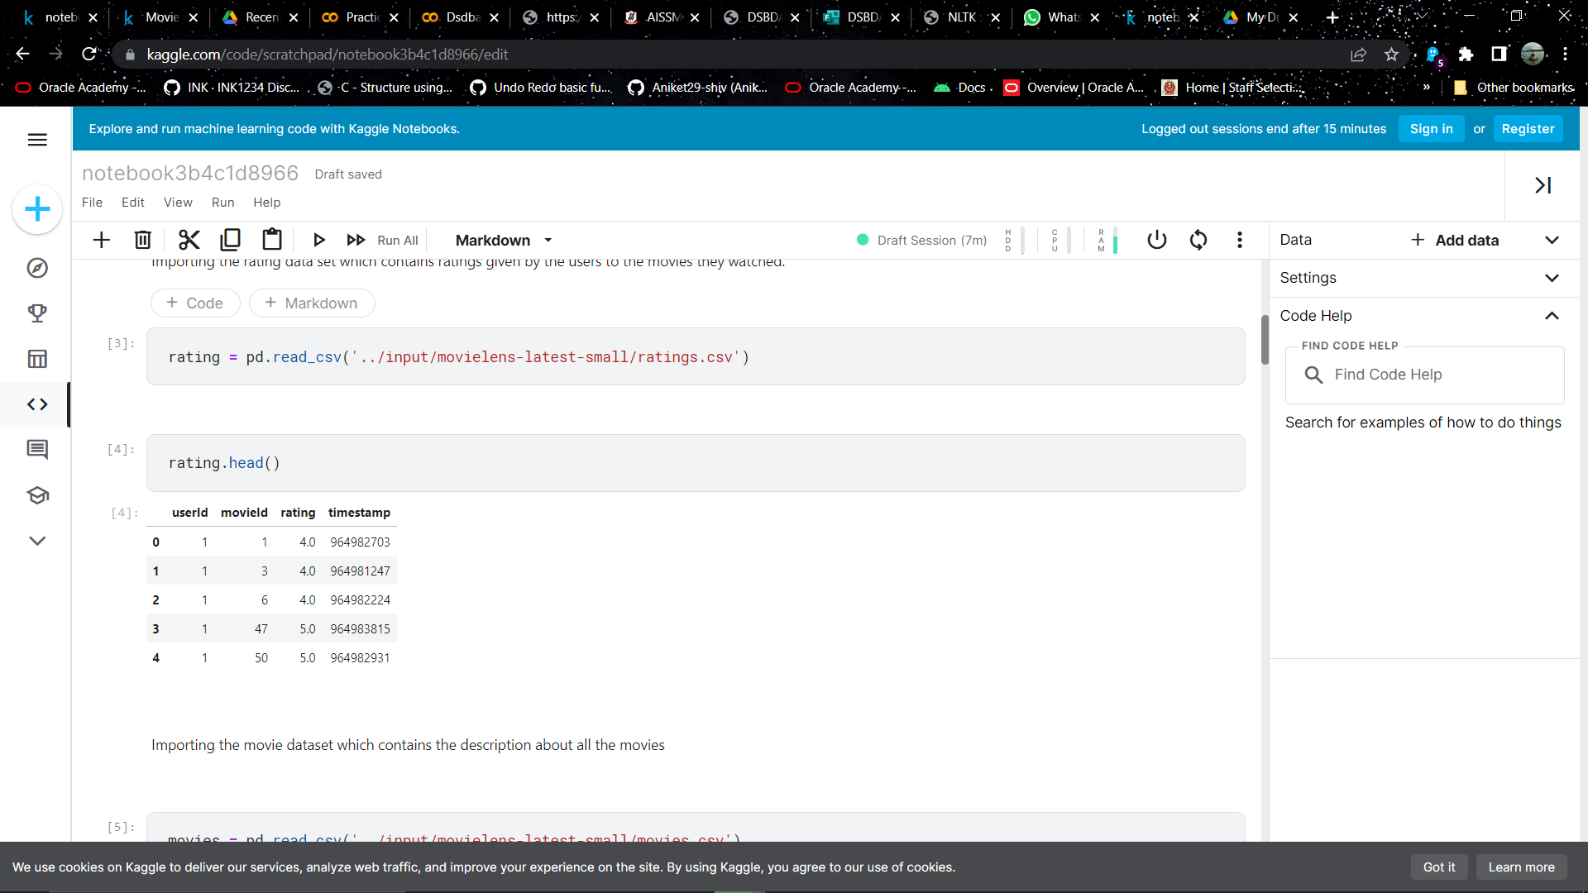

Read Dataset:

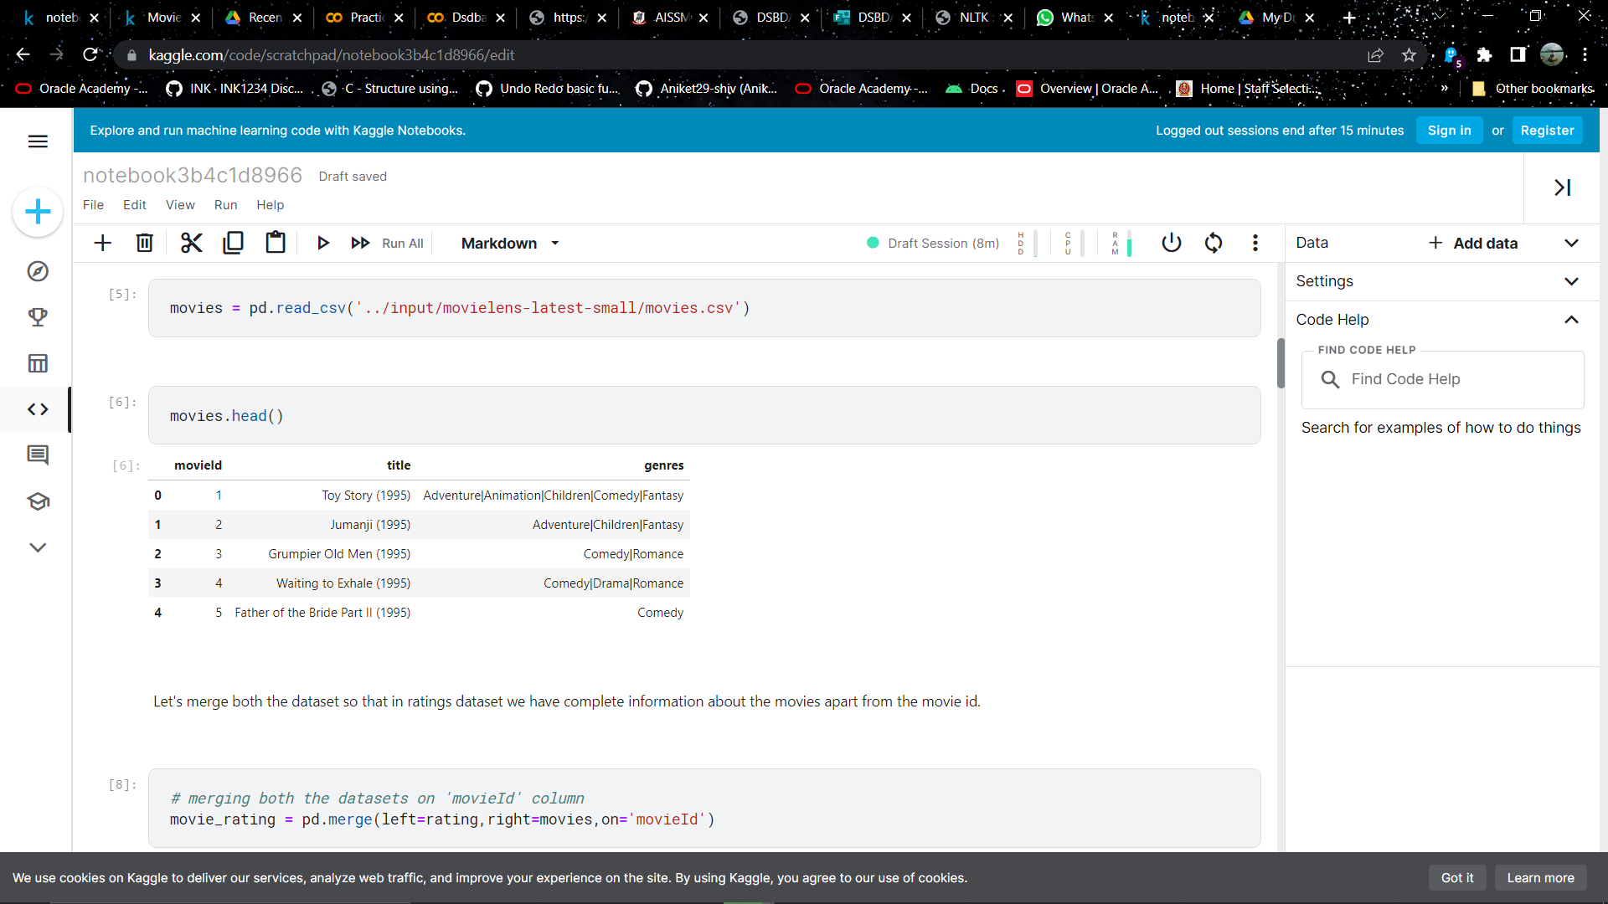

Merging Datasets:

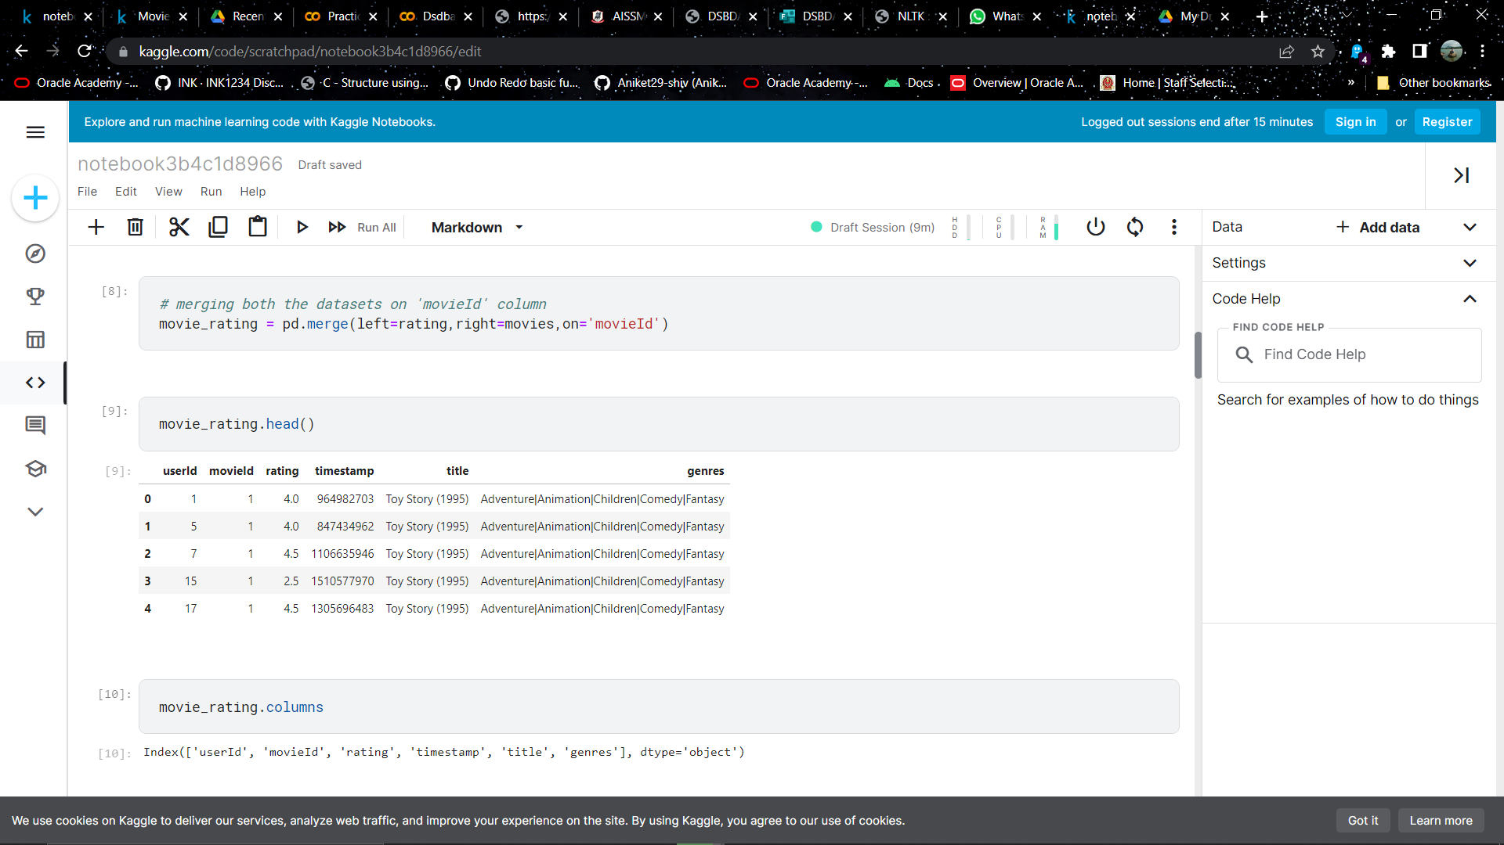

Exploratory Data Analysis :

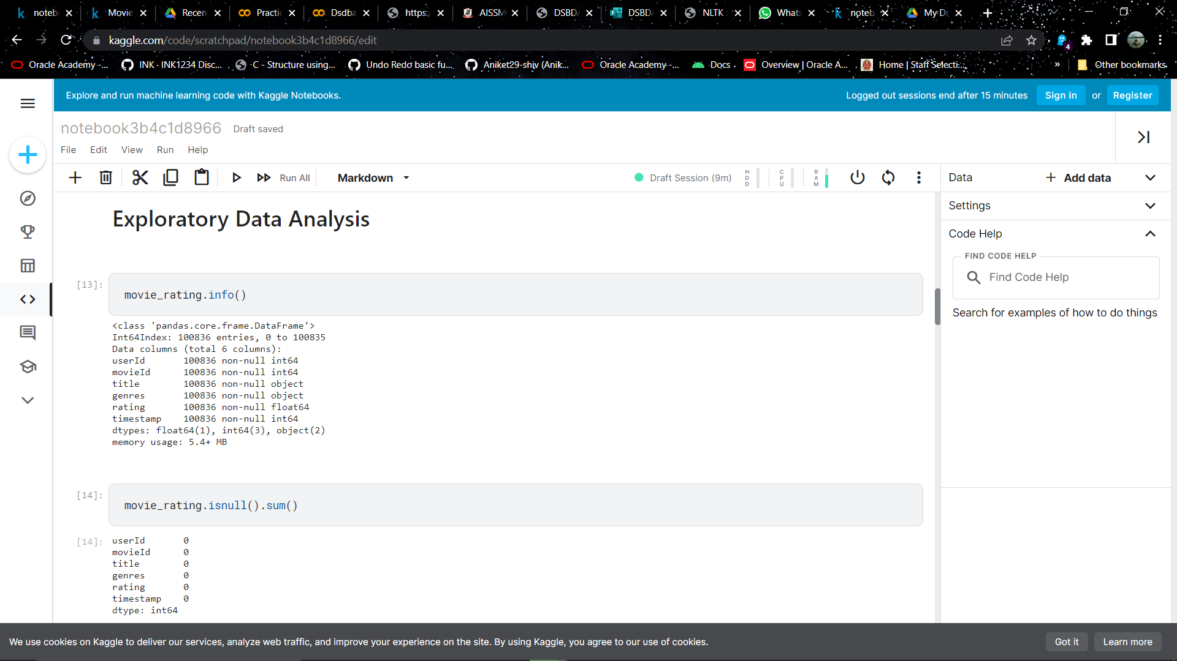

Grouping Movies Based on Rating: 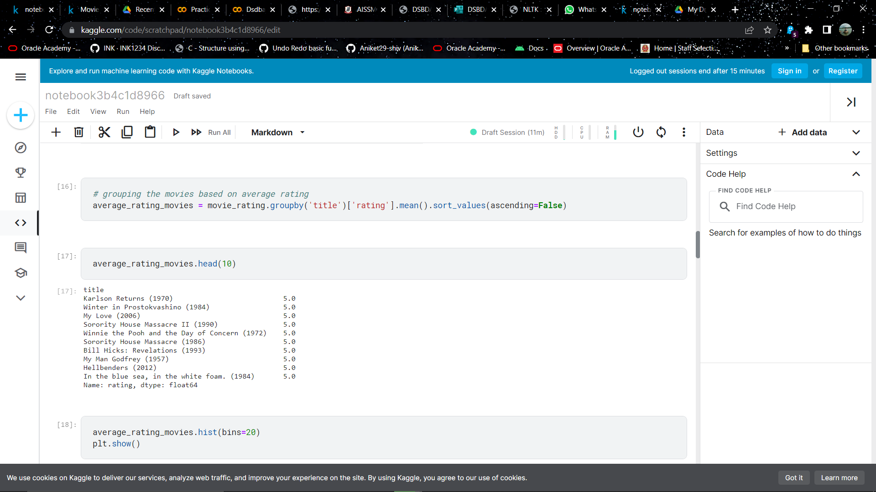

Graph Show: 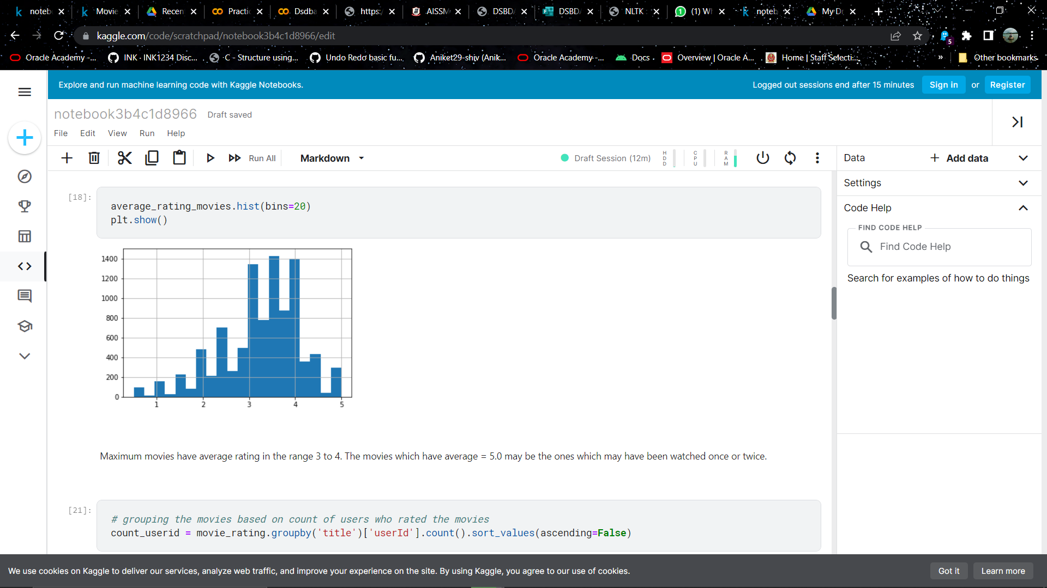

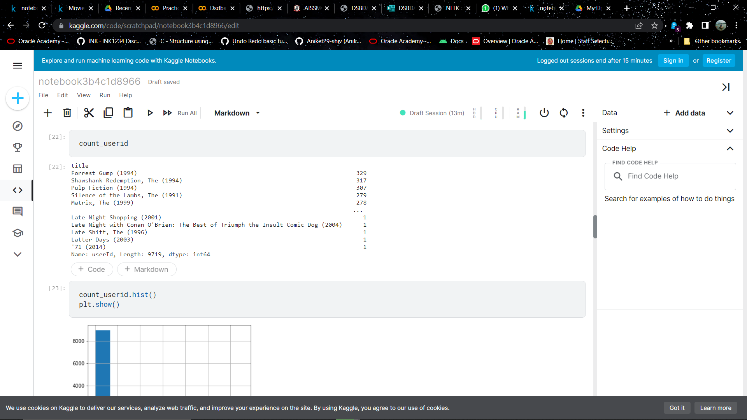

**Building Recommendation System:**

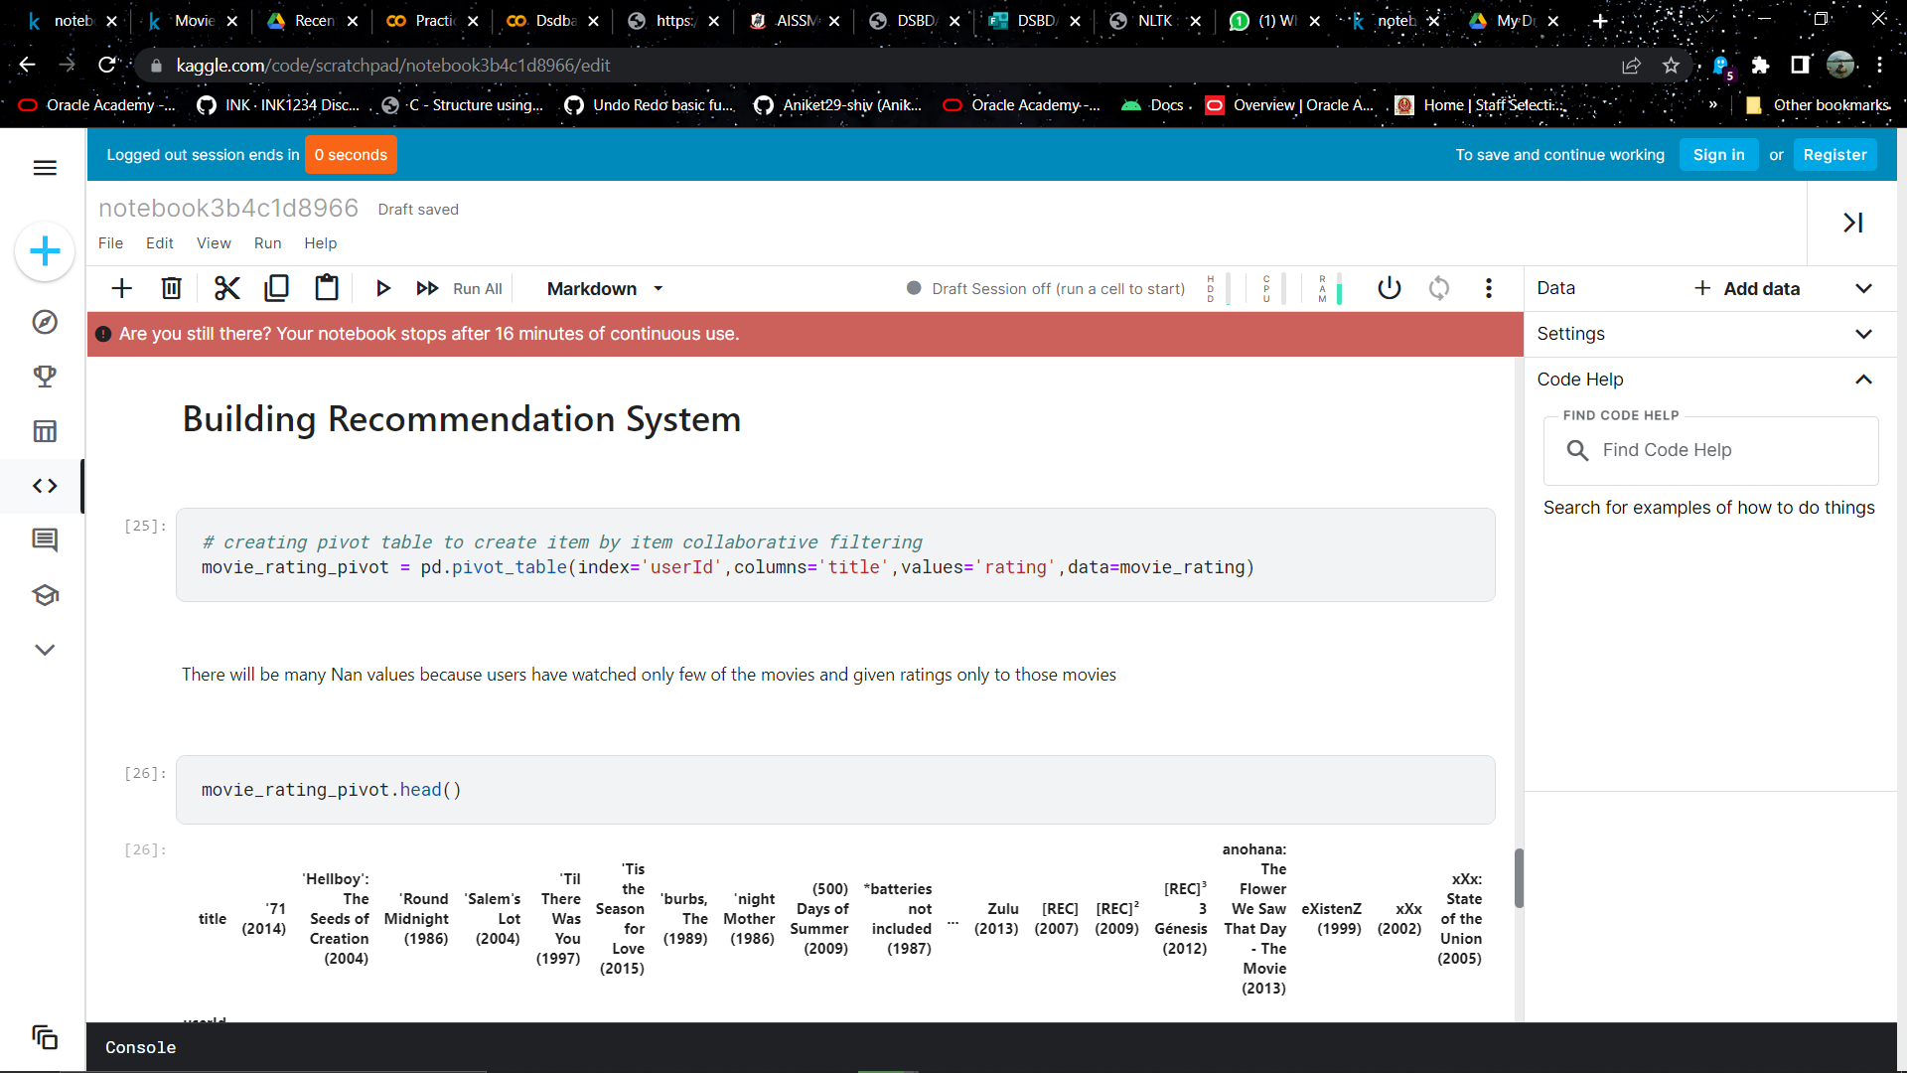

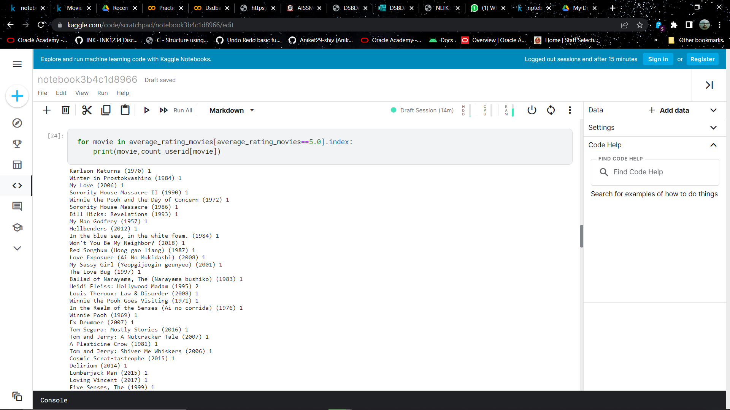

**Conclusion**

Social data is becoming more easily available to marketers. With the tools available to analyse and track the information, marketers can access key insights into their target audience. Using these metrics, marketers can ensure that their social media content is effective and justify social’s ROI.